# **PROJECT REPORT**

**INTRODUCTION :**

* **LOKSHABA ELECTION ANALYSIS OF 2019**
* Lok Sabha is the lower and the first house of the Parliament of India.
* Lok Sabha is the House of Representatives directly elected by the people.
* Hence, the Lok Sabha is called the 'First' house. The members of Lok Sabha are elected directly by people from the 'territorial constituencies'.
* Here, the analysis of the election which was held on 2019 had implemented by the datasets.
* **PURPOSE**
* By this analysis , the importance of votes can be understood by observing datasets.
* It can be further implemented to the every nook of the villages who were unaware of election and votes.

**PROBLEM DEFINITION & DESIGN THINKING :**

EMPATHY MAP 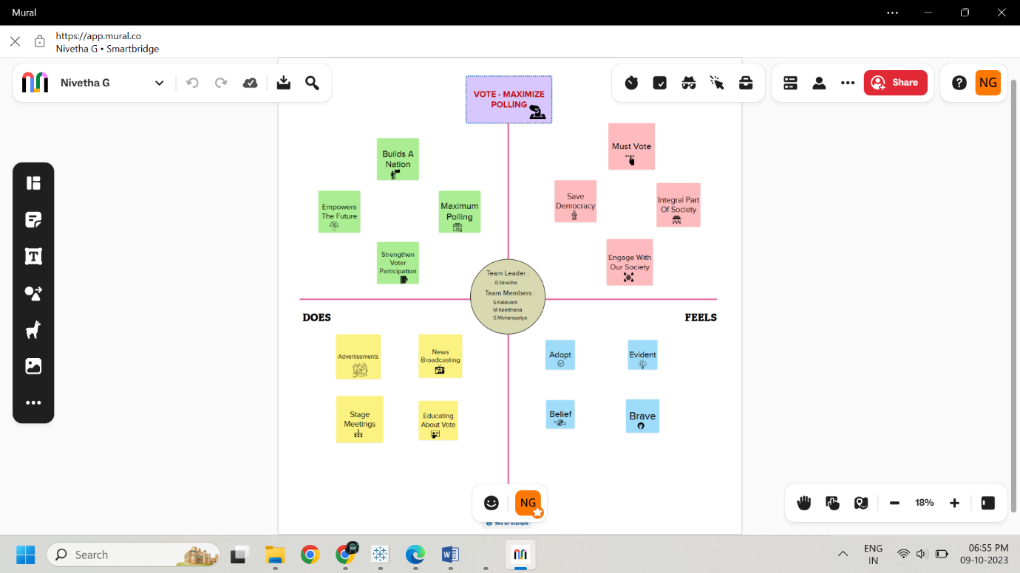

brAinsTorming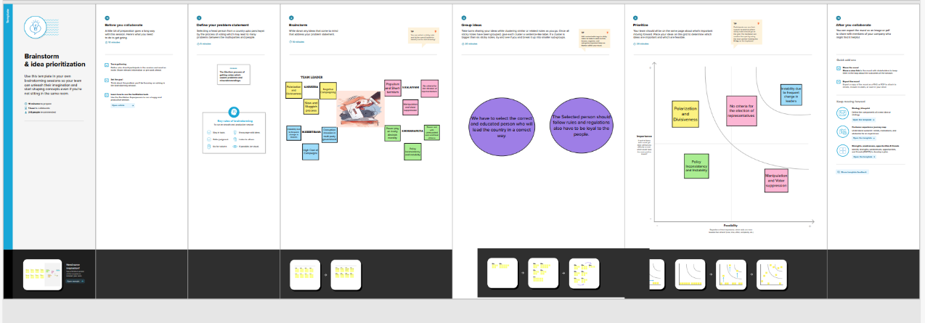

**RESULT :**

Data Model:

|  |  |
| --- | --- |
| **Object name** | **Fields in the Object** |
| KPI | |  |  | | --- | --- | | Field label | Data type | | Total Winner | Numbers | | Total Criminal Cases | Numbers | | Total Votes | Numbers | |
| GENERAL VOTES | |  |  | | --- | --- | | Field label | Data type | | Gender | Male & Female (Text) | | Education Qualification | Literates  Illiterates  School (Pass/Fail)  Graduates(Text) | |
| WINNER | |  |  | | --- | --- | | Field label | Data type | | State | Names (Text) | |
| STATES | |  |  | | --- | --- | | Field label | Data type | | General Votes | Numbers | | Postal Votes | Numbers | | |
| STATES | |  |  | | --- | --- | | Field label | Data type | | General Votes | Numbers | | Postal Votes | Numbers | | |
| CONSTITUENCY | |  |  | | --- | --- | | Field label | Data type | | Winner | Numbers | | Electors | Numbers | | |
| WINNERS | |  |  | | --- | --- | | Field label | Data type | | Education Qualification | Literates  Illiterates  School (Pass/Fail)  Graduates(Text) | | Category | Text | | |
| WINNERS | |  |  | | --- | --- | | Field label | Data type | | Party | Text | | |
| PARTY | |  |  | | --- | --- | | Field label | Data type | | Postal Votes | Numbers | | |

**ACTIVITY & SCREENSHOT:**

**DATA SOURCE**

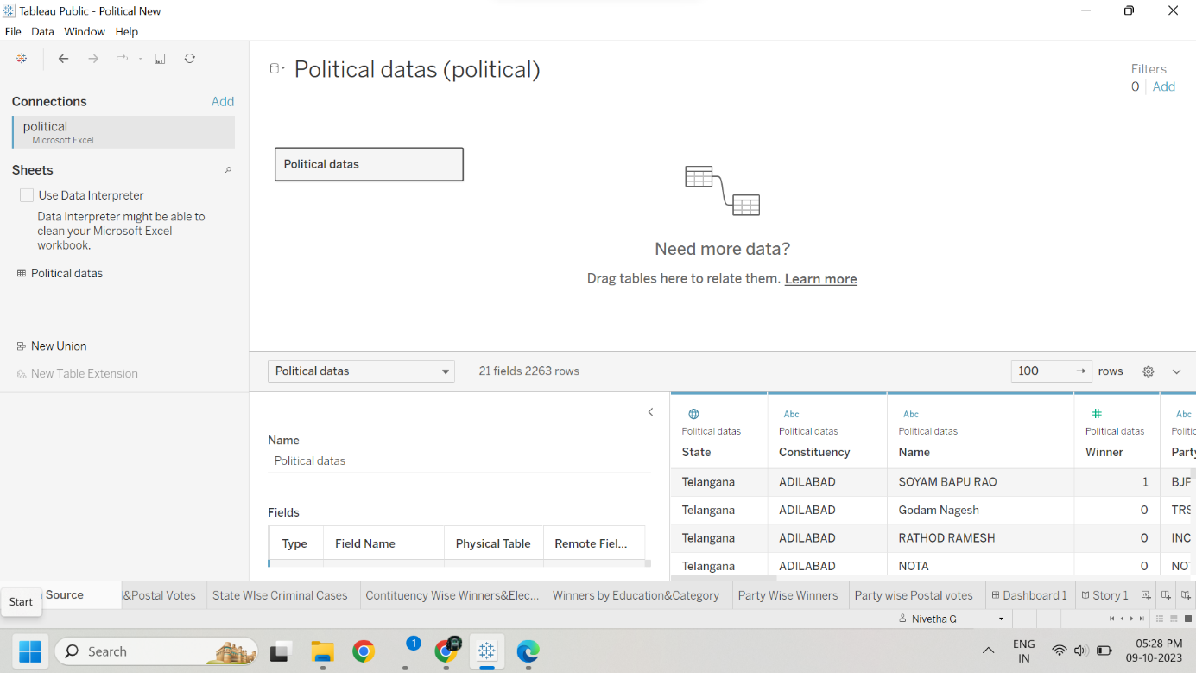

**KPI**



**KPI**

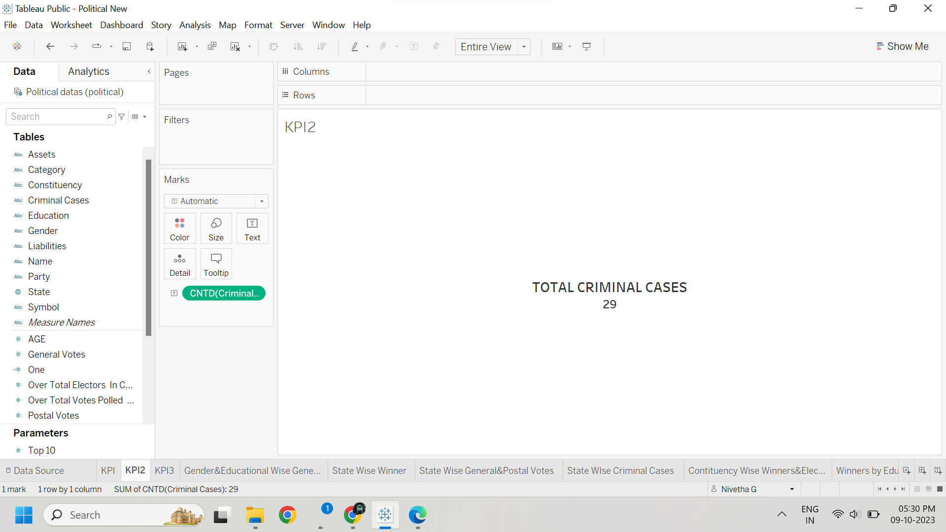

**KPI**

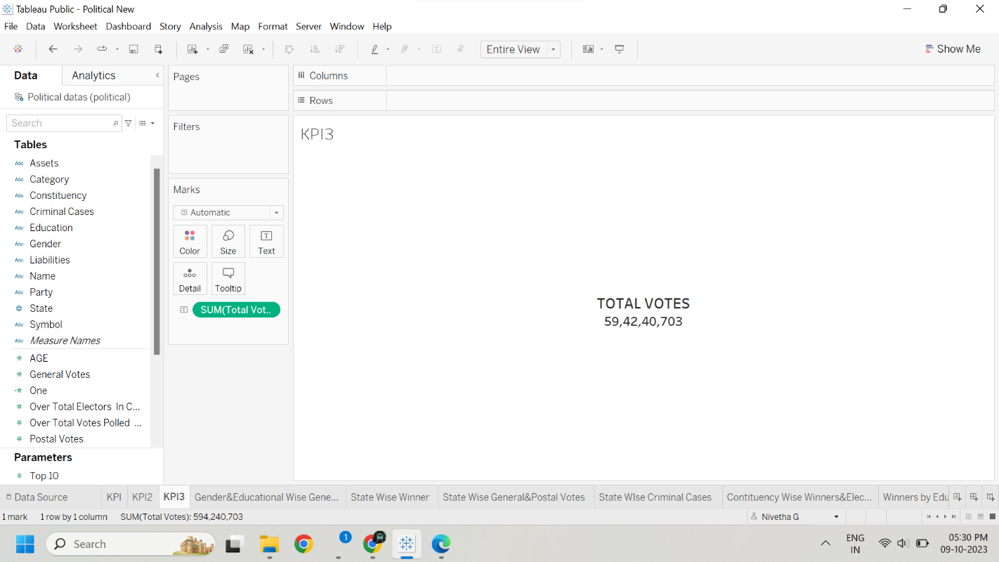

**Gender&Educational Wise General Votes**

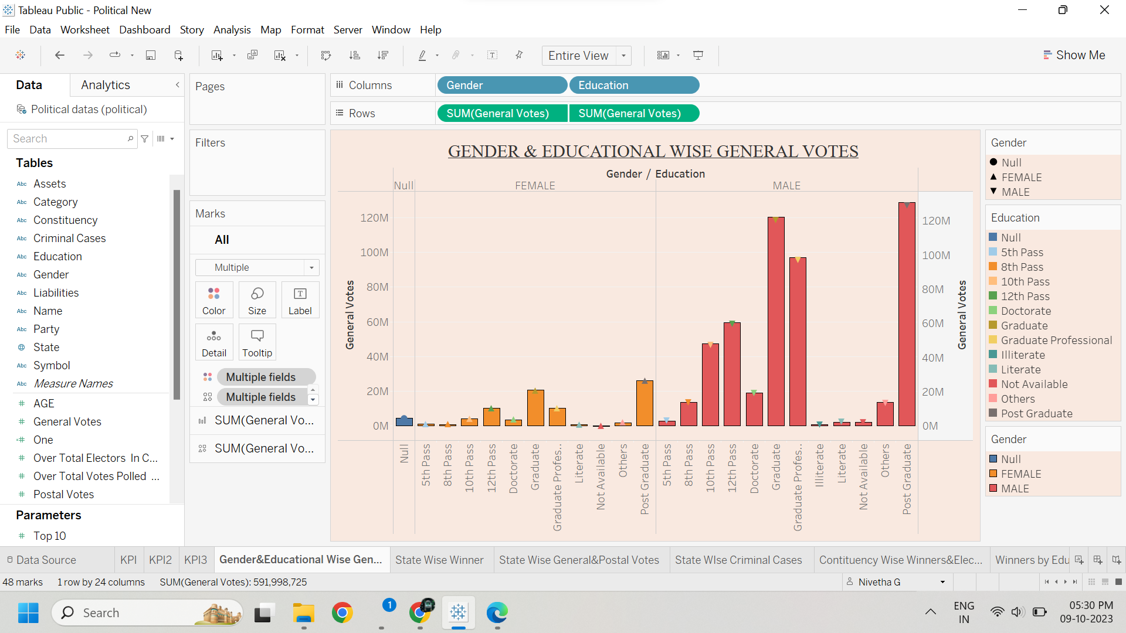

**State Wise Winner**

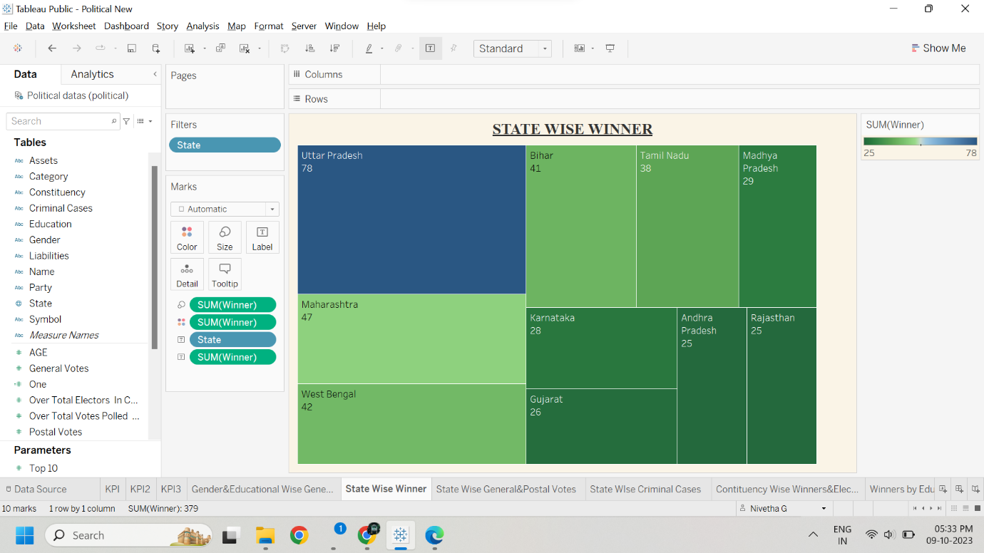

**State Wise General & Postal Votes**

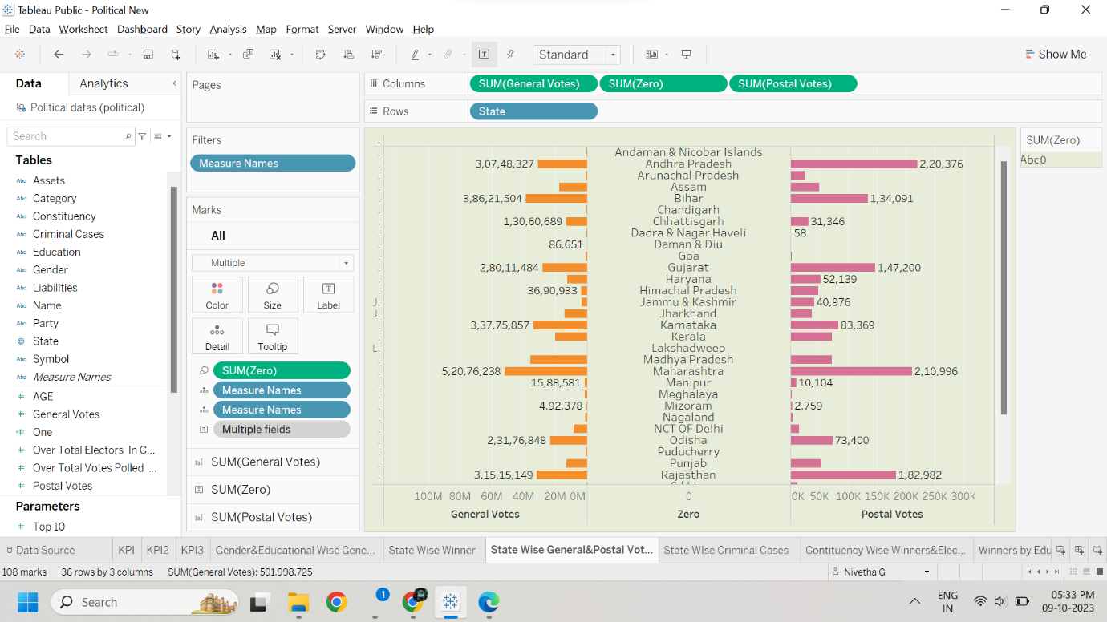

**State WIse Criminal Cases**

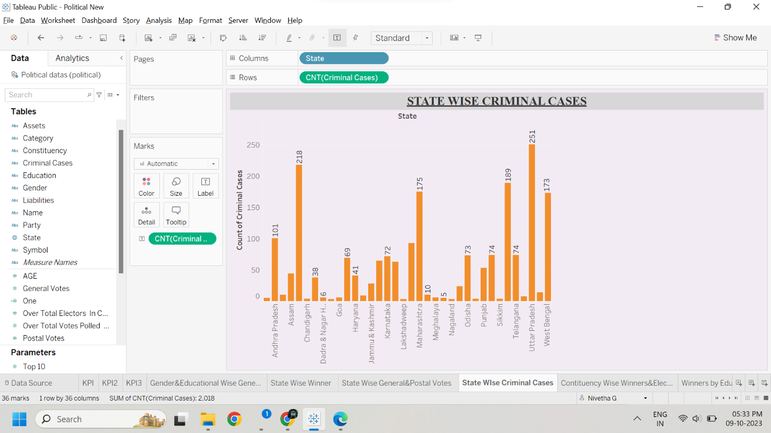

**Constituency Wise Winners & Electors**

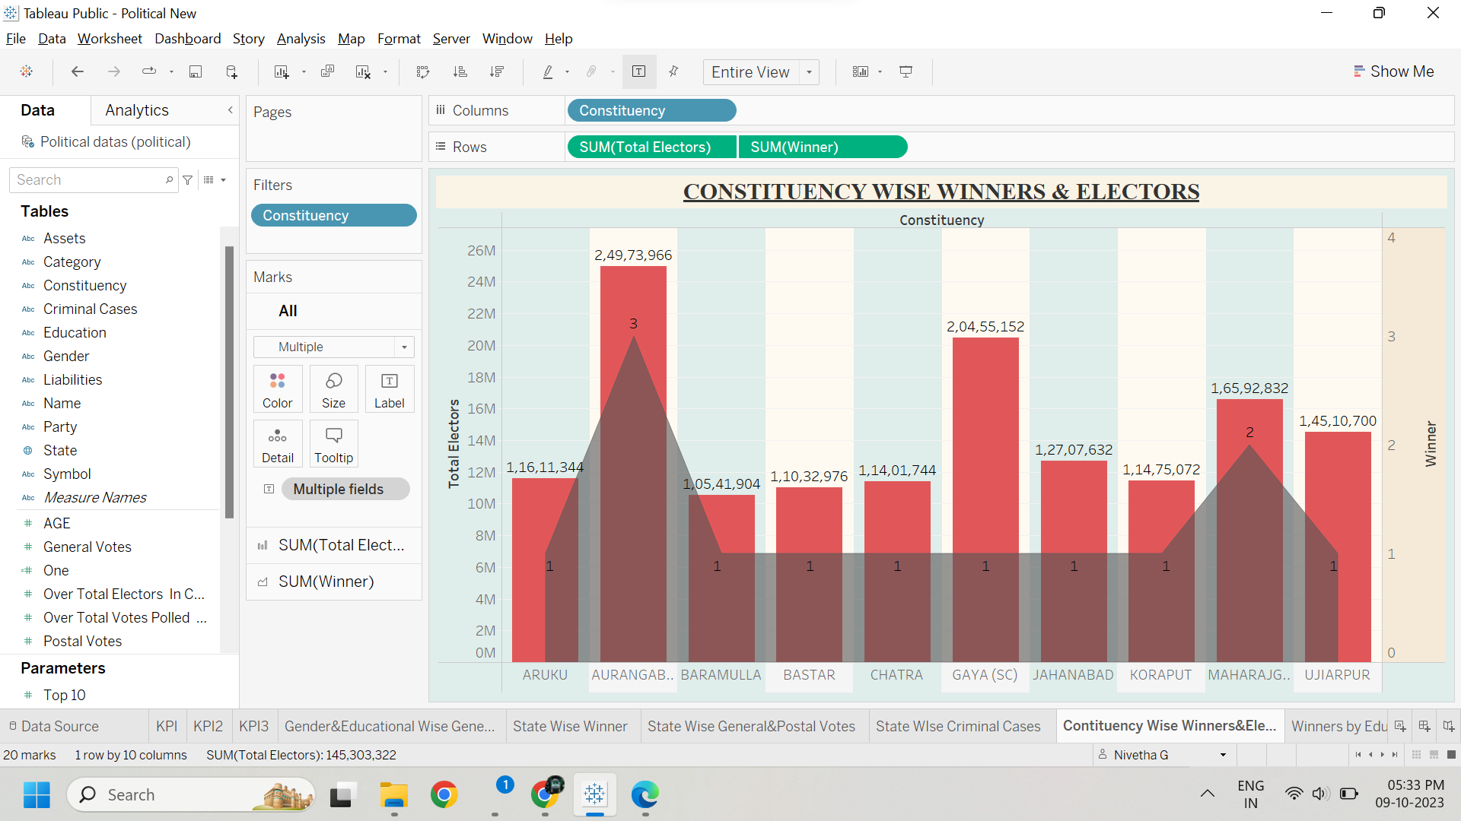

**Winners by Education & Category**

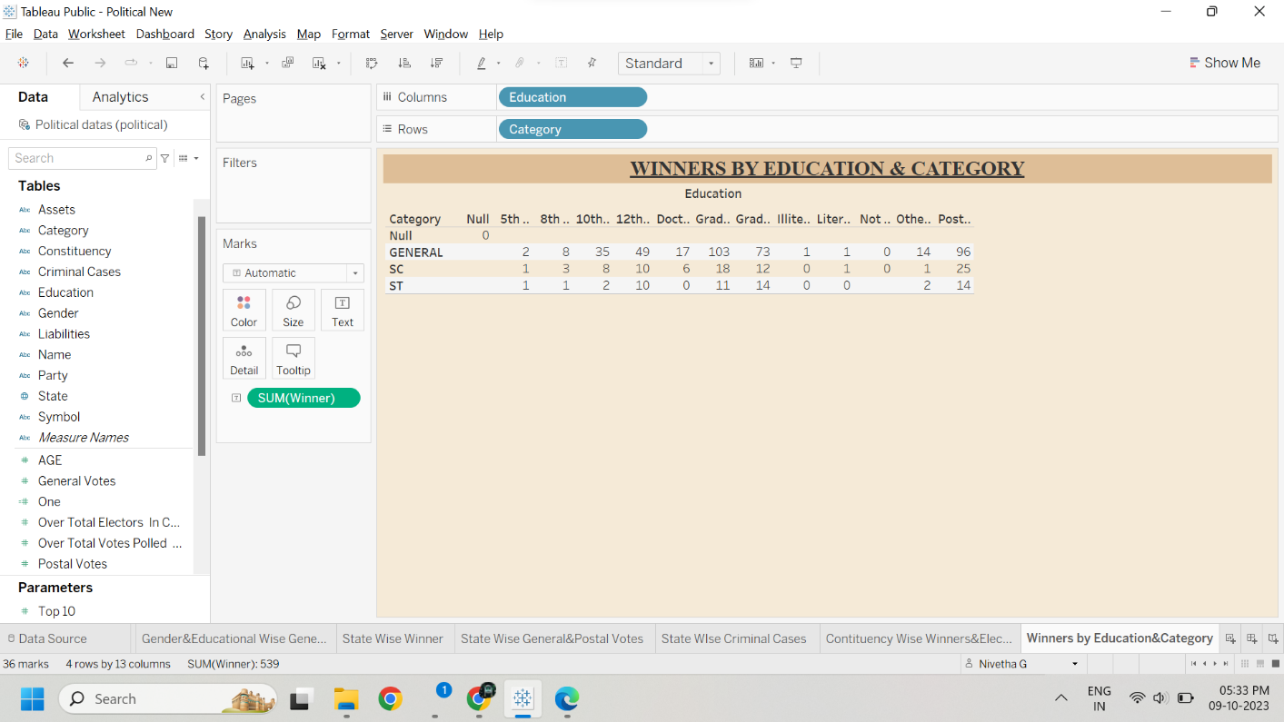

**Party Wise Winners**

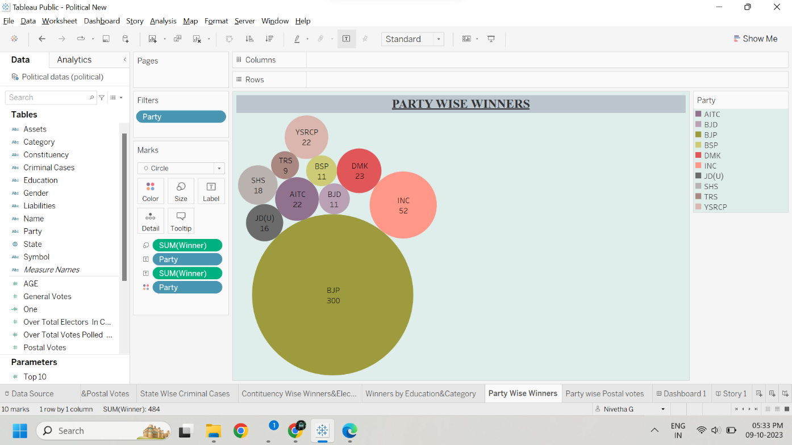

**Party wise Postal votes**

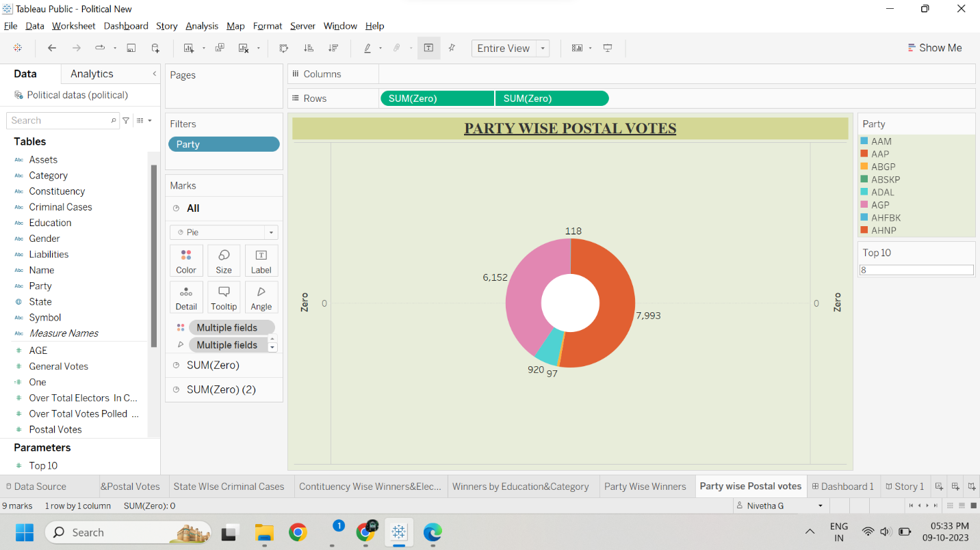

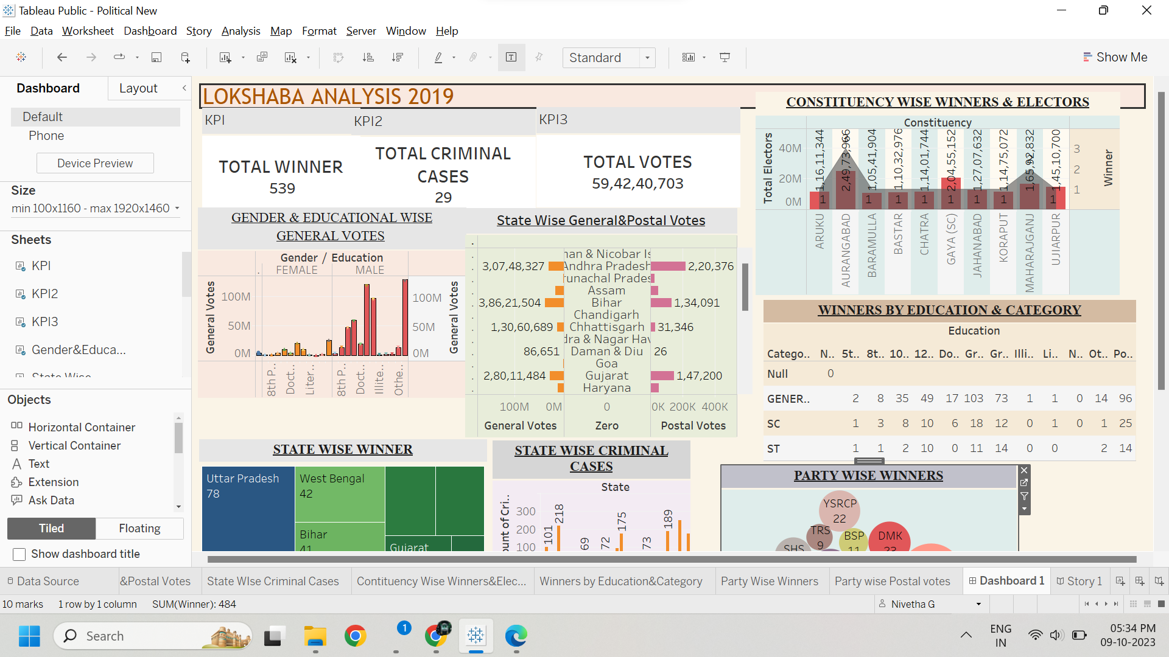**Dashboard 1**

**Story**

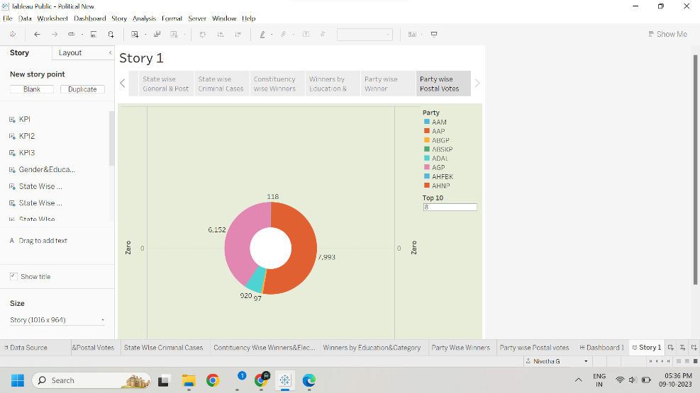

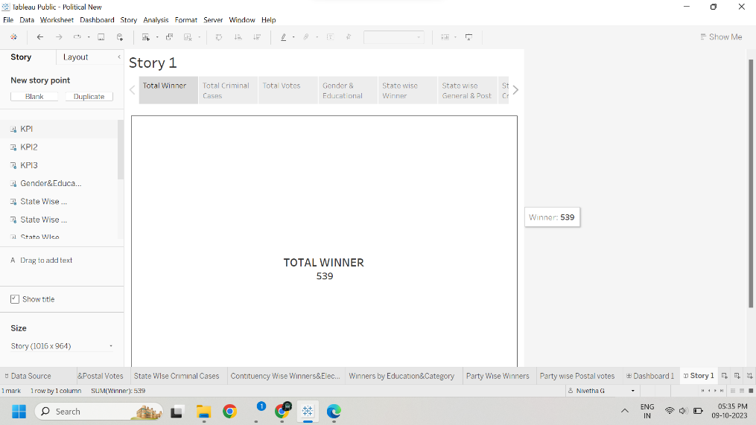

**ADVANTAGE & DISADVANTAGE :**

|  |  |
| --- | --- |
| ADVANTAGES | DISADVANTAGES |
| The Lok Shaba is more powerful than the RajyaShaba. | **Some members never participate in the debates and proceedings.** |
| It helps in proper functioning of democracy through the system of checks and balances. | **The rules are too rigid on facts and figures.** |
| No confidence motion can only be introduced and passed in the Lok Shaba. | **Professionals should be made ministers and should be approved by the Lok Shaba as done in USA and other countries.** |
| It controls the despotism of the government. | **The proceedings of Lok Shaba should be regular and for longer period.** |
| The voter turnout increases. | **No criteria for the election of representatives.** |
| It contributes to the stability of the government. | **Power play and rivalry diminish morality.** |

**APPLICATIONS :**

* The Lok Shaba has certain powers that make it more powerful than the Rajya Shaba.
* Motions of no confidence against the government can be introduced and passed in the Lok Shaba.
* If passed by a majority vote, the Prime Minister and the Council of Ministers resign collectively.
* The Candidates were elected by the people’s direct opinion.

**CONCLUSION :**

* An election is considered the prime pillar of democracy.
* Not only for the country but the election can also be conducted in any case where public opinion matters the most.
* An election is also defined as a decision-making process within a group of people sharing similar interests.
* Election gives us the power to choose the best leader in every session.
* If one is not performing up to the mark, he can be replaced in the next voting session.
* All we need is proper awareness of the public for making the right decisions.

**FUTURE SCOPE :**

* The challenge of developing electronic voting systems is not only security but also protecting the secrecy of the ballot, a bedrock principle of free and fair elections.
* Online and block chain-based voting would greatly increase the risk of undetectable, nation-scale election failures.
* End-to-end verifiable software can be integrated into existing election systems to enhance the security of voting infrastructure